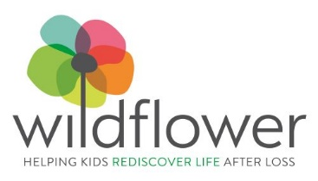
Rodman Zoom Meeting
25 June 2020

Wildflower: Helping Kids Rediscover Life After Loss
Team Wildflower & the Rodman Ride for Kids
How to Recruit Riders
Build a Campaign: 100 Riders $1,000 Each Support 100 Kids
- Create potential rider list
- Email an invitation to join Team Wildflower and follow up with phone call

Create Fundraising Page for each rider
- Send follow up email once their page is live to login info
- Follow up with phone call to get the rider excited about the event

Present ideas for virtual activities
- We used Rodman’s samples

Recruit Ride Captains
- Tap energetic donors to spread the word about the ride
- Send outreach materials under their signatures

Promote the Rodman Incentives – Add your own, too

Support materials – sample fundraising letters, talking points

Questions?
Laura Krotky
Director of Communications
781 325-2320
lkrotky@wildflowerforkids.org

