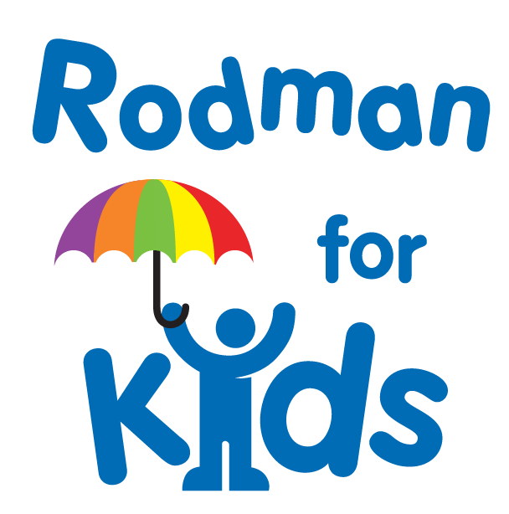

Dear XXX,

I hope that this EMAIL / LETTER finds you well. I’m writing to let you know that I am participating in the 32nd Annual Rodman Ride for Kids event because I believe that all young people deserve access to the programs, resources, and opportunities they need to dream, grow, and succeed. ADD A NOTE HERE ABOUT WHY THIS CAUSE AND ORGANIZATION ARE IMPORTANT TO YOU. PERSONAL DETAILS MAKE A HUGE DIFFERENCE!

The Rodman Ride for Kids offers over 40 youth-focused Partner Organizations a cost-free convening platform to raise funds for their programs and engage in collaborative opportunities. So far, the Rodman Ride for Kids has raised more than $150 million and continues to impact tens of thousands of kids each year.

This year, I will be ENTER ACTIVITY HERE (examples: riding 25 miles, riding 50 miles, walking, etc.) for ENTER PARTNER ORGANIZATION HERE. Please consider donating to my campaign** and help me reach my goal of XXX. 100% of your contribution will support the work of ENTER PARTNER ORGANIZATION HERE.
On behalf of myself, ENTER PARTNER ORGANIZATION HERE, and the kids they serve, thank you.

Kind Regards,
YOUR NAME HERE
INCLUDE YOUR ADDRESS IN CASE PEOPLE WANT TO MAIL YOU A CHECK INSTEAD!

** CONSIDER LINKING YOUR DONORDRIVE PAGE TO THIS TO SAVE YOUR DONORS AN ADDED STEP!

